### 



Class Diagram

Văn Lang Admissions

# Revision Table

|  |  |  |  |
| --- | --- | --- | --- |
| Author | Date | Reason for changes | Version |
| Tài Nguyễn | 20/02/2017 | Initial Document | 1.0 |
| Khoi Nguyen | 24/5/2017 | Fix logo | 1.1 |
|  |  |  |  |

Table of Contents

Revision Table 1

1. INTRODUCTION 3

1.1. Purpose 3

1.2. Audience 3

2. Class Diagram 3

2.1. Class GUI 3

2.1.1. Class Account GUI 3

2.1.2. Class News GUI 4

2.1.3. Class Categories GUI 4

2.1.4. Class Homepage GUI 5

2.1.5. Class Examination GUI 5

2.1.6. Class Banners GUI 6

2.1.7. Class Pop-ups GUI 6

2.1.8. Class FAQ GUI 7

2.2. Class BUS 8

2.3. Class DAO 9

# INTRODUCTION

## Purpose

This document shows class diagrams of functions.

## Audience

The main audiences of this document are: Mentor, Base Steps Solution Team.

# Class Diagram

## Class GUI

### Class Account GUI

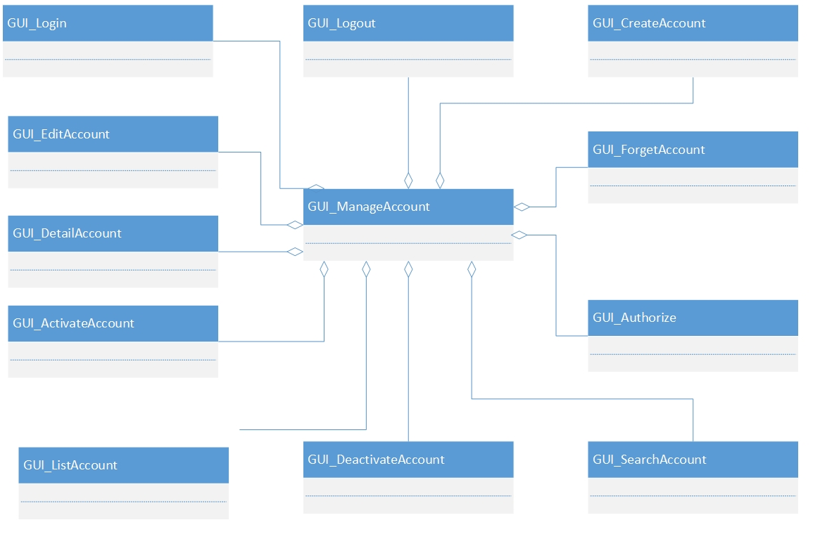

Figure 1: Class Manage Account GUI

### Class News GUI

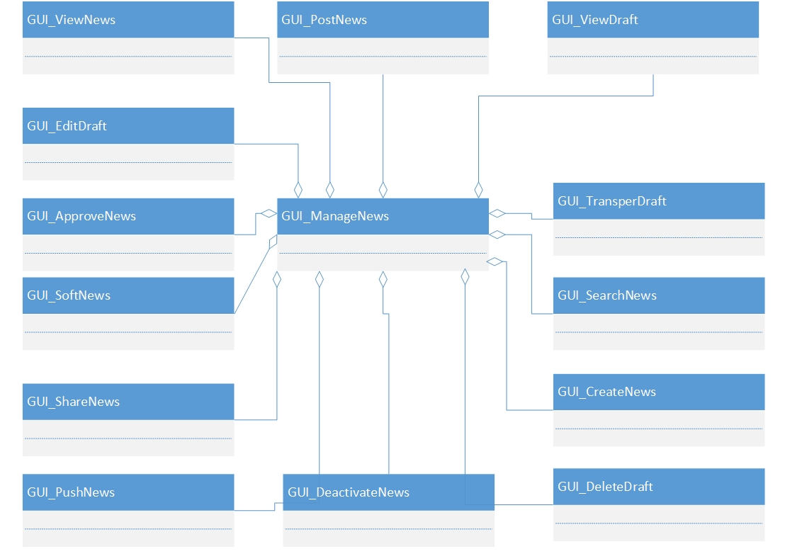

Figure 2: Class Manage News GUI

### Class Categories GUI

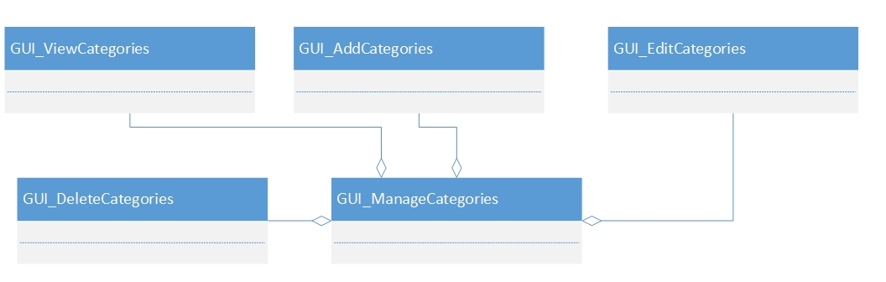

Figure 3: Class Manage Categories GUI

### Class Homepage GUI

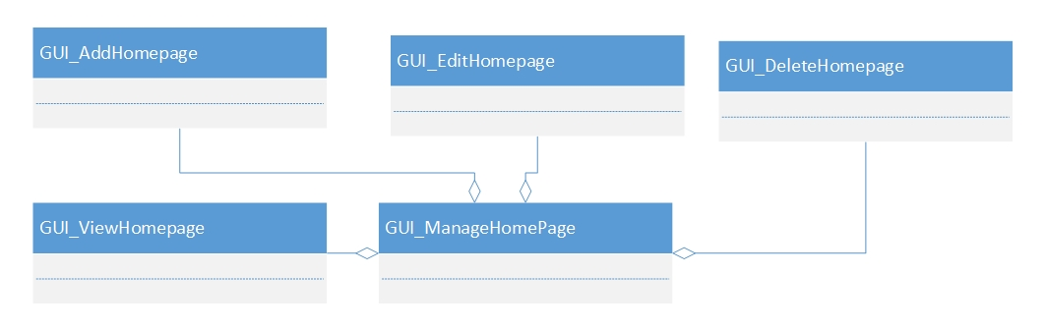

Figure 4: Class Manage Homepage GUI

### Class Examination GUI

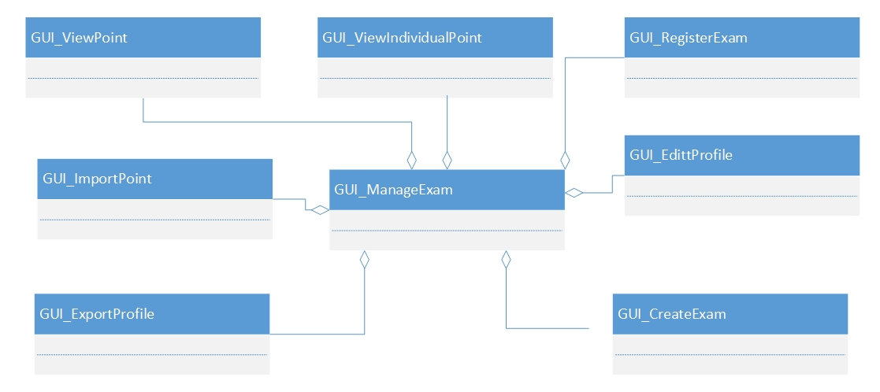

Figure 5: Class Manage Examination GUI

### Class Banners GUI

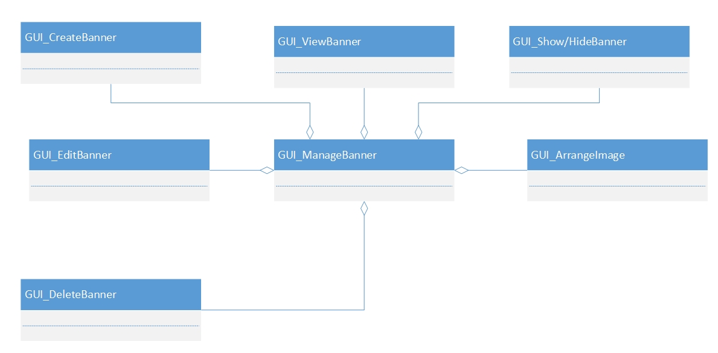

Figure 6: Class Manage Banners GUI

### Class Pop-ups GUI

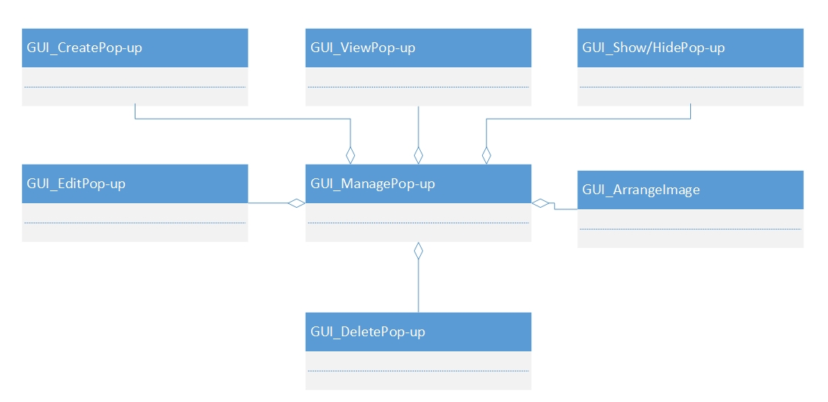

Figure 7: Class Manage Pop-ups GUI

### Class FAQ GUI

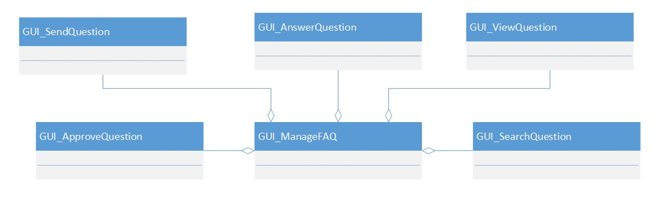

Figure 8: Class FAQ GUI

## Class BUS

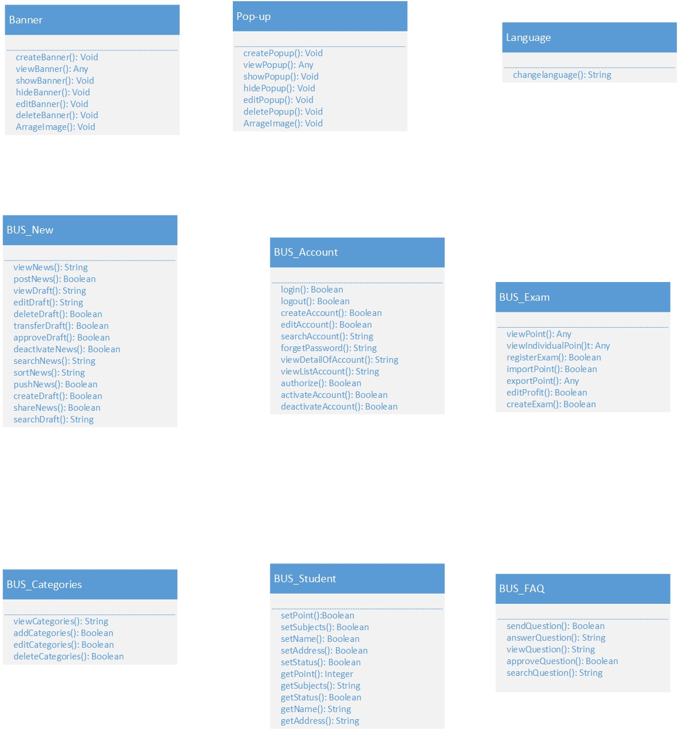

Figure 9: Class BUS

## Class DAO

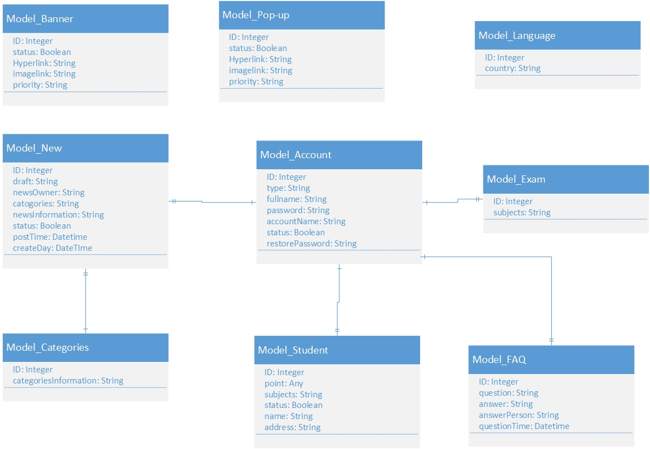

Figure 10: Class DAO